# Layout Parser API

Specifications

|  |  |
| --- | --- |
| Swagger URL | <https://ilocr.iiit.ac.in/layout/docs> |
| URL | <https://ilocr.iiit.ac.in/layout/> |
| Method | **POST** |
| Headers | {“Content-Type”: “multipart/form-data”} (Auto-generated) |
| Files | **images**: The image to be processed is uploaded. |
| Payload | **model:** choice of the model values can be “v2_doctr” (printed) or “craft” (HW) |
| Response | Json response object containing the word level bounding boxes |
| Sample Code (Python) | **import** requests  url = "<https://ilocr.iiit.ac.in/layout/>"  payload = {'model': 'doctr'}  files = [  ('images', (  '<image-name>.jpg',  **open**('<path-to-image>.jpg', 'rb'),  'image/jpeg'  )  )  ]  headers = {}  response = requests.post(url, headers=headers, data=payload, files=files)  **print**(response.text) |
| Sample Code (cURL) | **curl --location --request POST '**[**http://ilocr.iiit.ac.in/layout/**](http://ilocr.iiit.ac.in/layout/)**' \**  **--form '**[**images=@"<path-to-image>.jpg**](mailto:images=@"<path-to-image>.jpg)**"' \**  **--form 'model="****doctr"'** |

# Layout API (Swagger Demo):

<https://ilocr.iiit.ac.in/layout/docs#/Main/doctr_layout_parser_layout__post>

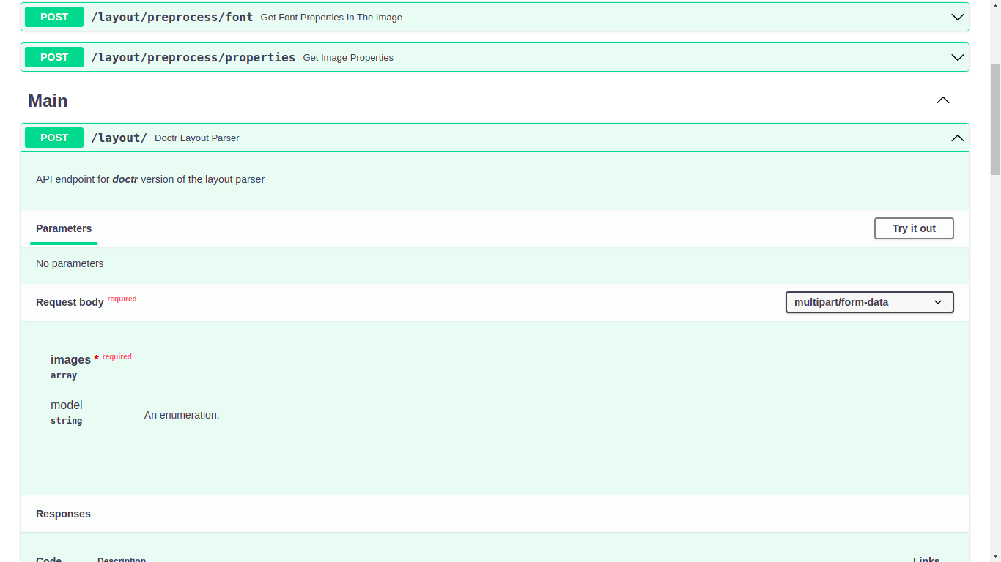

1. Click on “Try It Out”

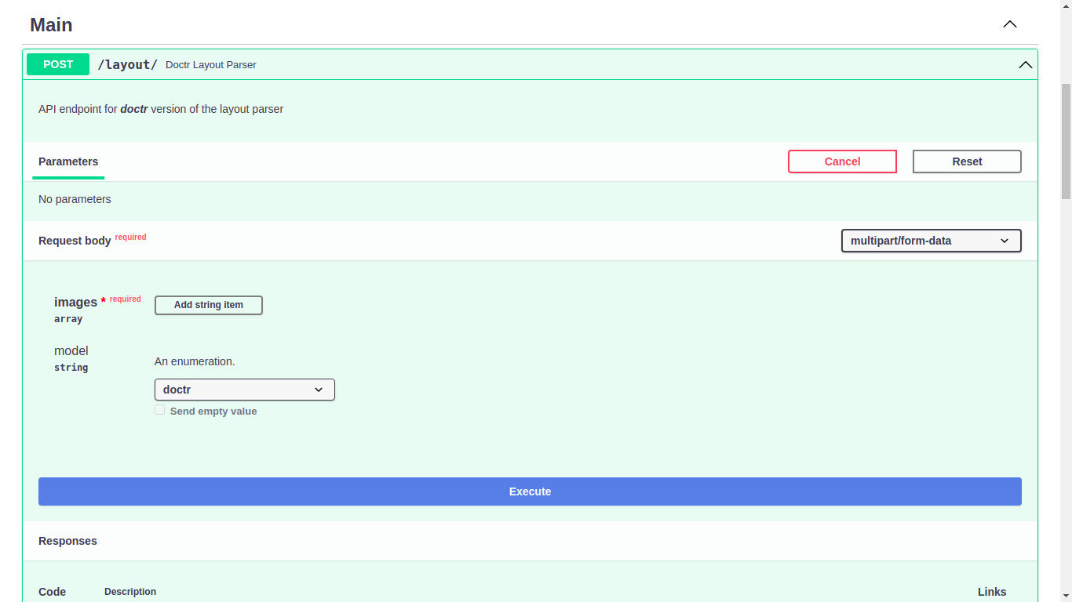

1. Select “**Add string Item**”

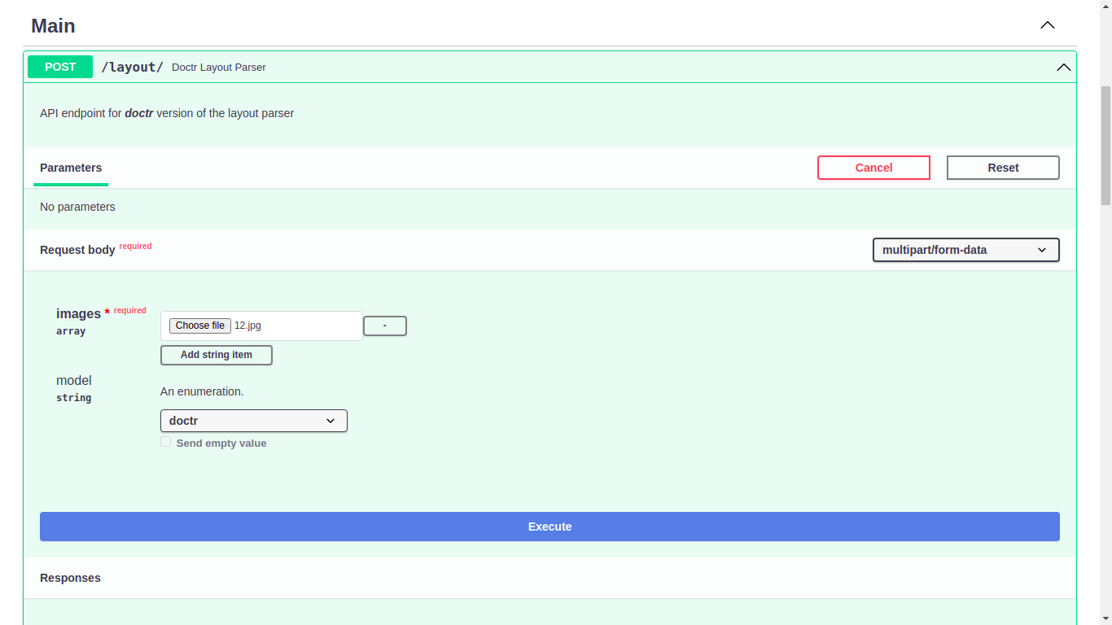

1. Upload the image (**in JPG format**) in “Choose File”.  
   And select appropriate model (2 options are provided “[craft](https://github.com/clovaai/CRAFT-pytorch)” and “[doctr](https://mindee.github.io/doctr/)”)  
   And click “**Execute**”.

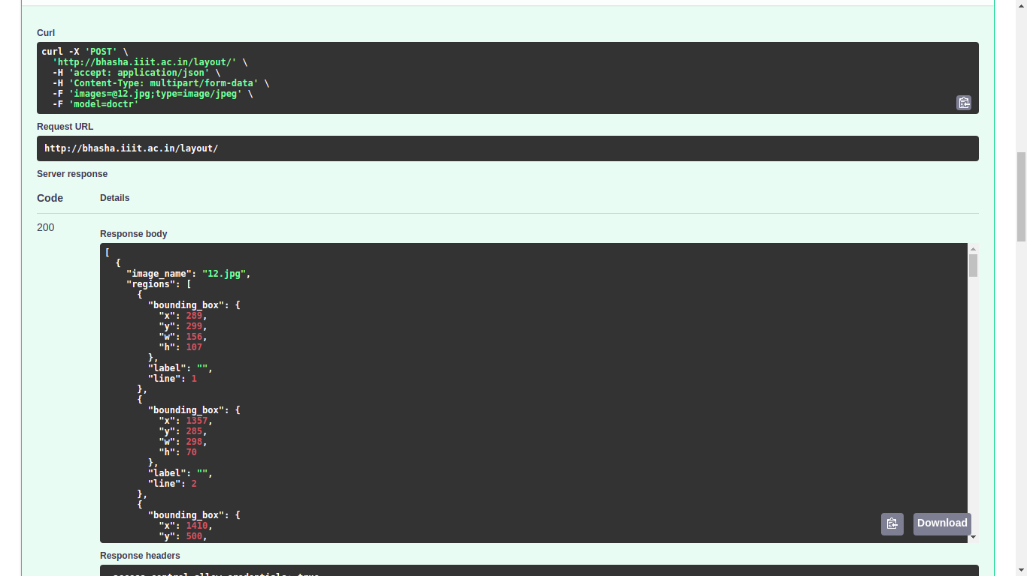

1. Output will be displayed in the “**Response Body”** in JSON format (as shown in the example.)

# Layout Visualization API (Swagger Demo):

<https://ilocr.iiit.ac.in/layout/docs#/Main/layout_parser_swagger_only_demo_layout_visualize_post>

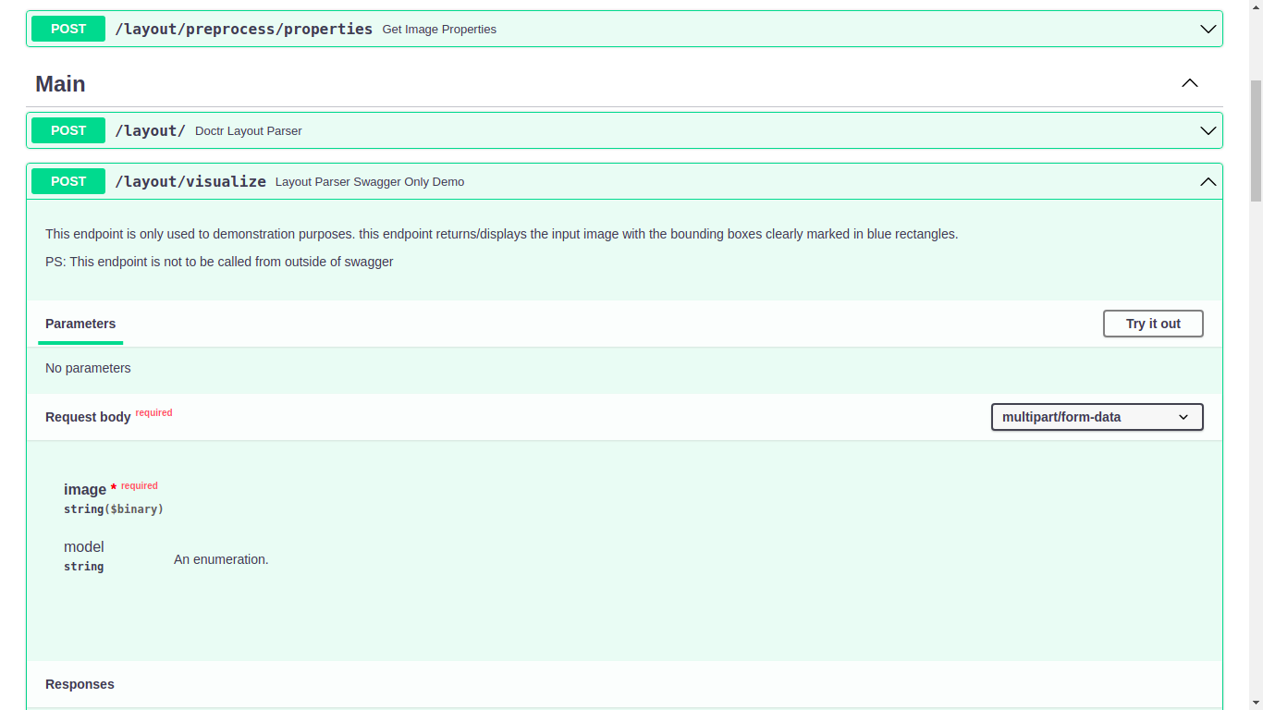

1. Click on “Try It Out”

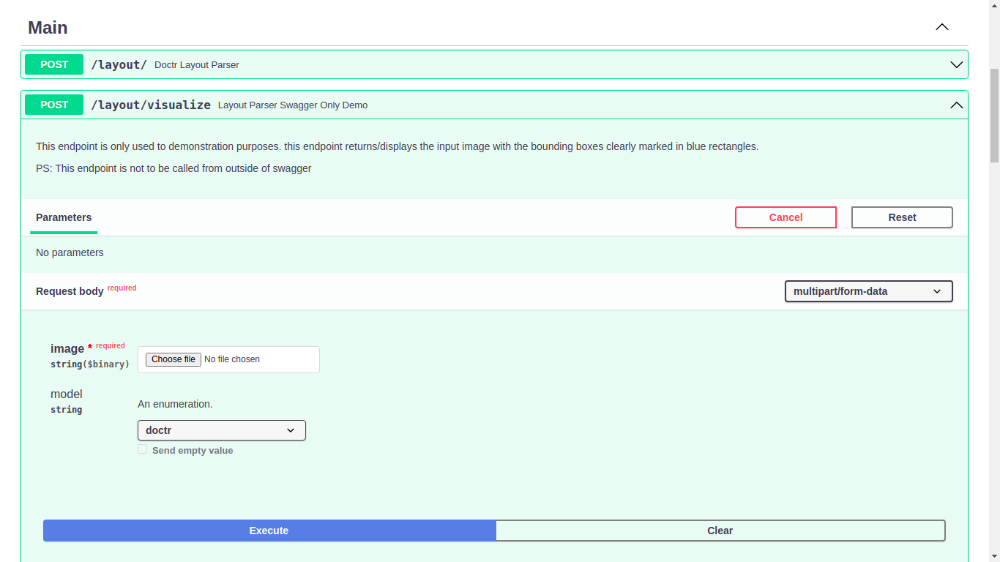

1. Upload the image (**in JPG format**) in “Choose File”.  
   And select appropriate model (2 options are provided “[craft](https://github.com/clovaai/CRAFT-pytorch)” and “[doctr](https://mindee.github.io/doctr/)”)  
   And click “**Execute**”.

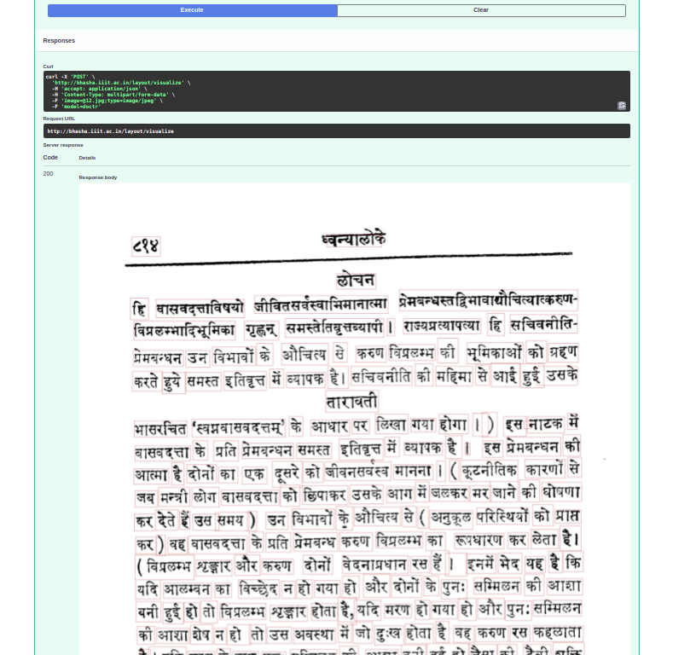

1. The output image will be displayed in the **Response Body** with the word level bounding boxes marked.